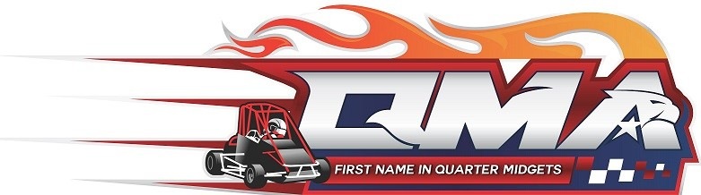

DRIVER CLASS MOVE-UP APPROVAL
DRIVER NAME: __________________________________________________
DRIVER AGE: _______________ DRIVER QMA #: __________________
HANDLER NAME: ________________________________________________
CLUB: _________________________ HANDLER QMA #: _________________
Date of Graduation: _____________
The above driver has been reviewed by the undersigned as being experienced and capable enough to run an upper-class motor as long as this driver also fits within the age bracket. The Class, this handler is requesting for his driver to run is (please circle):
JR/SR - Honda 160 Animal WF Half

__________________________  PARENT/HANDLER (print)  __________________________  NOVICE DIRECTOR (print)  __________________________  CLUB PRESIDENT (print)  __________________________  RACE DIRECTOR (print)  ___________________________  SAFETY DIRECTOR (print)  __________________________  TECH DIRECTOR (print) | __________________________  PARENT/HANDLER (signature)  _________________________  NOVICE DIRECTOR (signature)  __________________________  CLUB PRESIDENT (signature)  __________________________  RACE DIRECTOR (signature)  ___________________________  SAFETY DIRECTOR (signature)  __________________________  TECH DIRECTOR (Signature)

(1) Copy - club level and (1) copy National Office

